CSCE 5150: Analysis of Computer Algorithms

Homework-3

Name: Kishan Kumar Zalavadia

UNTID: 11685261

Submit a clear and well-explained answer. You can submit one answer per group. You can use the internet (but not paywall sites like Chegg) to look for answers, but the final answer must be in your own words. You can also use the code you found online for the experiments. Please cite all resources used for answers as well as codes.

**Q1.** Prove the following statements. Please write out the proof in detail, without skipping any vital steps. You can use figures to illustrate your work if necessary (6*10=**60 points**)

1. The center of a graph is the set of vertices with minimum eccentricity. Show that a tree can have either (i) exactly one vertex as a center or (ii) two vertices as centers, and these vertices will be connected by an edge.

**Ans**: Let T be a tree graph.

**Definitions:**

**Eccentricity:**

Eccentricity e(v) of vertex v is the maximum shortest path distance between v and all other vertices u in the graph.

**Center**

The center C(T) of a graph T consists of the set of all vertices with minimum eccentricity.

**Proof:**

**Case (i):** Center with Exactly One Vertex

Assume T has a center with exactly one vertex, say v.

This means ecc(v) is the minimum eccentricity in T.

**To Prove:**

There cannot be another vertex u in T with ecc(u) < ecc(v).

**Proof:**

Suppose there exists u with ecc(u) < ecc(v).

Since u has a lower eccentricity, it contradicts the assumption that v has the minimum eccentricity.

Therefore, there cannot be another vertex with a smaller eccentricity.

Hence Proved that the center of the tree T has exactly one vertex, and it is v.

**Case (ii):** Center with Two Vertices Connected by an Edge

Now, assume T has a center with two vertices, say u and v, and these vertices are connected by an edge.

**To Prove:**

For any other vertex w in T (w ≠ u, v), either ecc(w) = ecc(u) or ecc(w) = ecc(v).

**Proof:**

Suppose there exists a vertex w such that ecc(w) ≠ ecc(u) and ecc(w) ≠ ecc(v).

Without loss of generality, assume ecc(w) > ecc(u) and ecc(w) > ecc(v).

This contradicts the assumption that u and v form the center of the tree, as w has a greater eccentricity.

Therefore, for any other vertex w, either ecc(w) = ecc(u) or ecc(w) = ecc(v).

Hence Proved that the center of the tree T has two vertices, u and v, connected by an edge, and for any other vertex w, either ecc(w) = ecc(u) or ecc(w) = ecc(v).

**Final Conclusion:**

A tree can have either exactly one vertex as a center or two vertices as centers, and these vertices will be connected by an edge.

Reference: https://www.geeksforgeeks.org/graph-measurements-length-distance-diameter-eccentricity-radius-center/

1. Any tree with at least two vertices has at least two vertices of degree 1

**Ans: Proof:**

**Base Case:**

For a tree with two vertices, both vertices have degree 1, and the statement holds.

**Inductive Step:**

Assume the statement holds for any tree with n vertices, where n >= 2.

**Prove for a Tree with (n+1) Vertices:**

Consider a tree T' with (n+1) vertices and let ‘u’ be a leaf vertex of T' (a vertex with degree 1).

Remove the leaf vertex ‘u’ from T', and the remaining graph is still a tree.

Removing a leaf vertex does not disconnect the tree, as there is another path to reach every vertex.

The resulting graph is still connected and acyclic, satisfying the properties of a tree.

The tree T' with (n+1) vertices becomes a tree with n vertices after removing a leaf vertex.

By the inductive hypothesis, the tree with n vertices has at least two vertices of degree 1.

**Conclusion:**

Therefore, any tree with at least two vertices has at least two vertices of degree 1.

1. Two non-isomorphic trees can have the same degree of distribution

**Ans**:

Consider two non-isomorphic trees, T1 and T2.

The degree distribution of a tree is the list of degrees of all its vertices.

T1 and T2 can have the same degree distribution.

Non-isomorphic trees can still have the same degree distribution if the arrangement of edges around vertices is different but results in the same list of degrees.

**Example:**

Consider two trees T1 and T2 as shown in the below figure.

**Explanation:**

Although T1 and T2 are non-isomorphic, they have the same degree distribution {1, 3, 1, 2, 2, 4, 1, 1, 1}.

**Conclusion:**

Two non-isomorphic trees can indeed have the same degree distribution.

1. The upper bound on the number of articulation points in a graph is the number of biconnected components minus 1

**Ans:**

Let G be a connected graph.

A biconnected component of G is a maximal biconnected subgraph of G.

A biconnected graph is one where removing any single vertex (and its incident edges) does not disconnect the graph or make it acyclic.

An articulation point (cut vertex) v in a connected graph G is a vertex that when removed (with its incident edges) disconnects G into two or more separate subgraphs.

Let there be k biconnected components B1, B2, ..., Bk in graph G.

Now consider any two biconnected components Bi and Bj which share a common vertex. Let this common vertex be x.

Then x must be an articulation point in G. Because if x is removed, then Bi and Bj will become disconnected from each other since they were only connected through x.

Similarly, take any pair of biconnected components in G, their common vertex must be an articulation point.

Since there are k components, at most k-1 articulation points can exist - 1 connecting each pair of components.

Therefore, the maximum possible articulation points = Number of biconnected components - 1.

Thus proved that the upper bound on articulation points in graph G is the number of its biconnected components minus 1.

1. G is a simple graph with n vertices n>=2, and at least [(n-1)(n-2)/2 ]+1 edges. Prove that G is connected

**Ans:**

**Definition: Simple Graph**

A simple graph is an undirected graph that has no loops and no more than one edge between any two distinct vertices.

**To Prove**: G is Connected

If G is a simple graph with n vertices and at least [(n-1)(n-2)/2 ]+1 edges, then G is connected.

**Proof by Contradiction**

Suppose for the sake of contradiction, that G is not connected.

This would imply that there are at least two distinct connected components in G.

**We know**:

If G is not connected, then the number of edges in G is less than the number of edges in a connected graph with n vertices, which is given by [(n-1)(n-2)/2 ].

**Contradiction**:

However, G has at least [(n-1)(n-2)/2 ]+1 edges, which is greater than the number of edges in a connected graph with n vertices.

This contradicts the assumption that G is not connected.

Therefore, G must be connected, as the assumption that G is not connected leads to a contradiction.

1. Show that if v is an articulation point in graph G, then it cannot be an articulation point in the complement graph of G.

**Ans: Proof:**

**Definition: Articulation Point**

An articulation point in a graph is a vertex whose removal increases the number of connected components in the graph.

**Definition: Complement Graph**

The complement graph of G denoted as G', is a graph that has the same vertices as G, but two vertices are adjacent in G' if and only if they are not adjacent in G.

**To Prove**: v is not an Articulation Point in G'

If v is an articulation point in graph G, then it cannot be an articulation point in the complement graph of G, G'.

**Proof by Contradiction:**

Suppose for the sake of contradiction, that v is an articulation point in both G and G'.

This would imply that the removal of v increases the number of connected components in both G and G'.

**We know**:

If v is an articulation point in G, then the removal of v increases the number of connected components in G.

If v is an articulation point in G', then the removal of v increases the number of connected components in G'.

**Contradiction**:

However, the number of connected components in G and G' are complementary.

If the removal of v increases the number of connected components in G, then it decreases the number of connected components in G'.

Therefore, v cannot be an articulation point in both G and G'.

**Conclusion:**

Therefore, if v is an articulation point in graph G, then it cannot be an articulation point in the complement graph of G, G'.

**Q2. Chain of numbers (20)**

Given the set of positive integers from 1 to 15, arrange all of them in a sequence such that the sum of consecutive numbers in the sequence is a perfect square.  
For example if part of the sequence is (9,7,2,14); 9+7=16; 7+2=9;2+14=16, etc.

Show that solving this problem from any number n is equivalent to solving the  
Hamiltonian path problem. Here solving means either finding the sequence or identifying that such a sequence, including all numbers, cannot be formed. (10)

Explain your method and show step by step how you obtained your sequence for (2*5=10)

1 to 15  
1 to 16

**Ans**:

**Graph Construction:**

**Vertices**: Create a graph with vertices labeled from 1 to 15 (or 1 to 16, depending on the problem statement).

**Edges**: Connect two vertices with an edge if the sum of the corresponding numbers is a perfect square.

For example:

Connect 1 and 8 since 1 + 8 = 9 (a perfect square).

Connect 2 and 14 since 2 + 14 = 16 (a perfect square).

Continue this process for all pairs of numbers.

The resulting graph should have edges connecting numbers whose sum is a perfect square.

**Hamiltonian Path Problem:**

Now, let's understand how solving the given problem is equivalent to finding a Hamiltonian path in this graph.

**Hamiltonian Path:**

A Hamiltonian path is a path that visits every vertex exactly once.

**Application to the Problem:**

If a Hamiltonian path exists in our graph, it means there is a sequence of consecutive numbers such that the sum of any two consecutive numbers is a perfect square.

**Procedure to Find the Sequence:**

1. Start at any vertex.
2. Move to an adjacent vertex that has not been visited yet.
3. Continue until all vertices are visited.

**Example (1 to 15):**

**Graph Construction:**

Vertices: 1, 2, 3, 4, 5, 6, 7, 8, 9, 10, 11, 12, 13, 14, 15.

Edges: Connect vertices if the sum is a perfect square.

Connect 1 and 3 (1 + 3 = 4).

Connect 1 and 8 (1 + 8 = 9).

Connect 1 and 15 (1 + 15 = 16).

Connect 2 and 7 (2 + 7 = 9).

Connect 2 and 14 (2 + 14 = 16).

Connect 3 and 6 (3 + 6 = 9).

Connect 3 and 13 (3 + 13 = 16).

Connect 4 and 5 (4 + 5 = 9).

Connect 4 and 12 (4 + 12 = 16).

Connect 5 and 11 (5 + 11 = 16).

Connect 6 and 10 (6 + 10 = 16).

Connect 7 and 9 (7 + 9 = 16).

Connect 10 and 15 (10 + 15 = 25).

Connect 11 and 14 (11 + 14 = 25).

Connect 12 and 13 (12 + 13 = 25).

**Hamiltonian Path Check:**

Now, check if there is a Hamiltonian path in this graph.

Start at any vertex, say 8.

8 → 1 → 15 → 10 → 6 → 3 → 13 → 12 → 4 → 5 → 11 → 14 → 2 → 7 → 9.

**Sequence:** 8, 1, 15, 10, 6, 3, 13, 12, 4, 5, 11, 14, 2, 7, 9

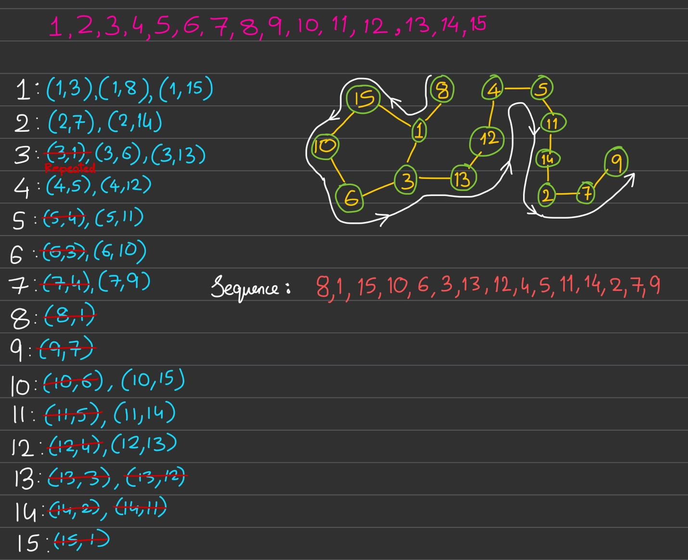

**Example (1 to 16):**

Add the vertex labeled "16" to the graph described above and determine whether there exists a Hamiltonian path in the updated graph.

16 is connected to 9 because 16 + 9 = 25 (perfect square).

**Hamiltonian Path :**

8 → 1 → 15 → 10 → 6 → 3 → 13 → 12 → 4 → 5 → 11 → 14 → 2 → 7 → 9 → 16.

**Sequence:** 8, 1, 15, 10, 6, 3, 13, 12, 4, 5, 11, 14, 2, 7, 9, 16

**Explanation:**

1. If there's a Solution to Our Problem:

If we can arrange the numbers in a sequence following the rules, it means we can find a path that visits each number exactly once in our graph. This path is what we call a Hamiltonian path.

1. If there's a Hamiltonian Path:

If we have a path that visits every number exactly once in our graph, then we can arrange the corresponding numbers in a sequence following the rules of our problem.

**Conclusion:**

If you can find a Hamiltonian path, then you have a sequence of consecutive numbers with the desired property. If there is no Hamiltonian path, then no such sequence exists.

**Q3. Water Jug Problem (20)**

You are given three jugs J1, J2, and J3 with capacities a, b, and c gallons respectively. Let a > b > c. There are no markings on the jugs, so they can be used to measure only their respective capacities. You can measure different amounts of liquid by pouring from one jar to another. Thus at each step, the following things will happen

1. (i)  One of the jars will remain unchanged
2. (ii)  one jar that was not completely filled will become full
3. (iii)  one jar which was not empty becomes empty.

Given that jug J1 is filled, develop an algorithm to measure exactly a given amount, x, of liquid using the three jars. [HINT: Express the different options of pouring the liquid as vertices in a graph and then and the shortest path from the start state to the end state].

(a) Clearly explain your algorithm with clear steps. You do not have to submit the code. (10)

**Ans:** Algorithm:

1. Represent each possible state of the jugs as a vertex in a graph. The vertices will represent every possible combination of water levels across the 3 jugs.
2. Connect two vertices with a directed edge if water can be poured between those two states in one pouring operation while following the rules (i), (ii), and (iii).
3. The initial state is vertex where J1 is full and J2 and J3 are empty. Mark this as the start vertex.
4. Mark the vertex with J1 having x gallons of water as the goal vertex.
5. Apply the BFS (breadth first search) algorithm to find the shortest path from the start vertex to the goal vertex.
6. The sequence of edges in the shortest path gives the steps for water-pouring operations.

(b) Show how it works for the example given above; 8(J1), 5(J2), and 3(J3) gallons and x=4. You should not just write the steps, but also explain how your algorithm is used to arrive at the steps. (10)

**Ans:**

Working for jugs of capacities 8 (J1), 5 (J2), and 3 (J3) gallons and x = 4 gallons:

All vertices: (8,0,0) , (3,5,0), (5,0,3), (3,2,3), (0,5,3), (5,3,0), (6,2,0), (2,3,3), (6,0,2), (5,3,0), (2,5,1), (1,5,2), (7,0,1), (1,4,3) , (7,1,0) , (4,4,0) , (4,1,3)

Start vertex is (8, 0, 0) Goal vertex is (4, anything, anything)

Applying BFS gives 2 shortest path

Path – 1 : (8,0,0) -> (3,5,0) -> (3,2,3) -> (6,2,0) -> (6,0,2) -> (1,5,2) -> (1,4,3) -> (4,4,0)

Path – 2 : (8,0,0) -> -> (5,3,0) -> (5,3,0) -> (2,3,3) -> (2,5,1) -> (7,0,1) -> (7,1,0) -> (4,1,3)

**Steps for Path-1/Solution-1 are:**

(8,0,0) -> Pour from J1 to J2 till J2 fills. J1 now has 3 gallons -> (3,5,0)

(3,5,0) -> Pour from J2 to J3 till J3 fills. J2 now has 2 gallons -> (3,2,3)

(3,2,3) -> Pour from J3 to J1. J3 becomes empty -> (6,2,0)

(6,2,0) -> Pour from J2 to J3. J2 becomes empty -> (6,0,2)

(6,0,2) -> Pour from J1 to J2 till J2 fills. J1 now has 1 gallon -> (1,5,2)

(1,5,2) -> Pour from J2 to J3 till J3 fills. J2 now has 4 gallons -> (1,4,3)

(1,4,3) -> Pour from J3 to J1. J3 becomes empty -> (4,4,0)

Now J1 has 4 gallons

**Steps for Path-2/Solution-2 are:**

(8,0,0) -> Pour from J1 to J3 till J3 fills. J1 now has 5 gallons -> (5,0,3)

(5,0,3) -> Pour from J3 to J2. J3 becomes empty -> (5,3,0)

(5,3,0) -> Pour from J1 to J3 till J3 fills. J1 now has 2 gallons -> (2,3,3)

(2,3,3) -> Pour from J3 to J2 till J2 fills. J3 now has 1 gallon -> (2,5,1)

(2,5,1) -> Pour from J2 to J1. J2 becomes empty -> (7,0,1)

(7,0,1) -> Pour from J3 to J2. J3 becomes empty -> (7,1,0)

(7,1,0) -> Pour from J1 to J3 till J3 fills. J1 now has 4 gallons -> (4,1,3)

Now J1 has 4 gallons

